
Module Detail |  | Trainee's Detail
SECTOR: | ICT | Reg No: | 24RP15022  24RP15067
SUB-SECTOR: | Information Technology | Class: | Level 8 Information Technology
 |  | Trainer's Detail
CERTIFICATE: | Bachelors of Technology | Name: | Jean Marie Vianney NYIRIMANA
MODULE  (Code &Title): | ITLDM801 - DATA MINING AND DATA WAREHOUSING | Additional info
Scored marks: |  | Decision: | Competent
 |  |  | Not Yet Competent

Store Books ETL and Data Warehouse

Project Report

Project Overview:

This project aims to transform the existing Store Books Sales database into a robust data warehouse, enabling advanced analytics and reporting capabilities. The project involves the use of Extract, Transform, Load (ETL) processes to migrate and transform data, and the implementation of SQL Server Analysis Services (SSAS) to create a cube for in-depth data analysis.

Tools and Technologies Used

Database Management Systems (DBMS)

Microsoft SQL Server (2022): for designing and managing the data warehouse.

SQL Server Management Studio (SSMS): for database management and query execution.

SQL Queries: for retrieving data from the source database and load them into Datawarehouse.

Data Modeling & Schema Design

Star Schema Design: Used as data warehouse structure.

Python: Data processing and transformation.
How the Store Books Data Warehouse Project implemented
Implement of Store Books Data Warehouse Project involves, ETL (Extract, Transform, Load) process which is a critical part of creating a data warehouse.
ETL involves:
- Extracting data from the source syste
- Transforming data to fit the warehouse schema,
- Loading data into the data warehous

- Extracting data from the source system
The Extract phase focuses on retrieving data from the gravity_books database. This step ensures that the necessary raw data is gathered for further processing and transformation.
Figure 1: Data source schema
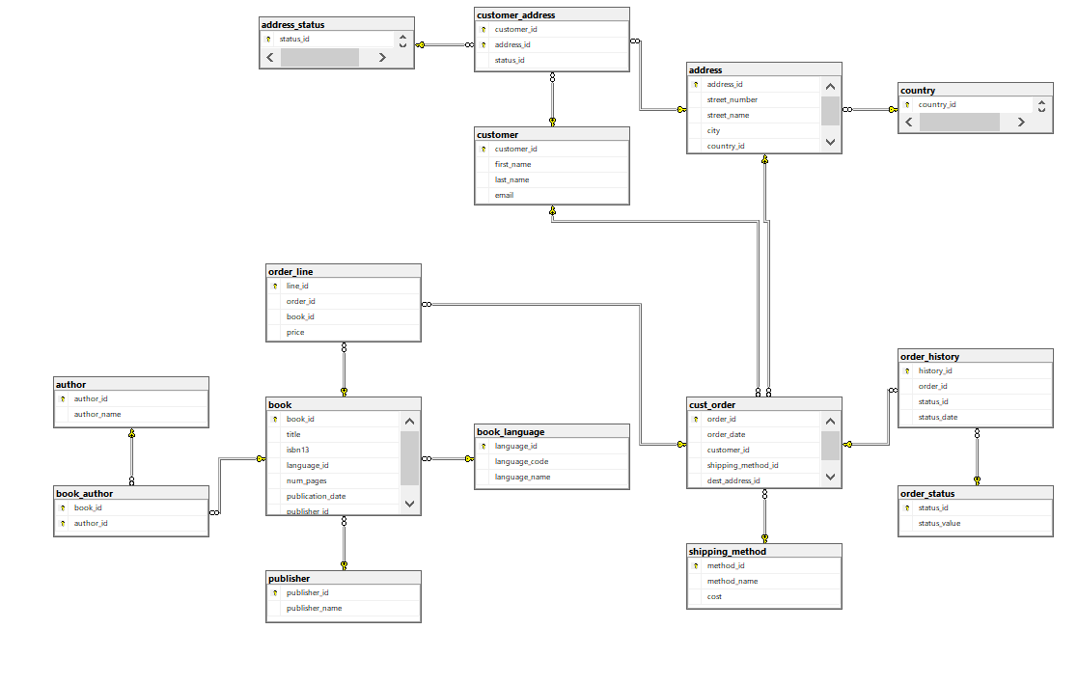
Data from Source Tables Database (gravity_books)
Import necessary libraries
import pyodbc
import pandas as pd
from datetime import datetime
import warnings
warnings.filterwarnings("ignore", category=UserWarning, message="pandas only supports SQLAlchemy connectable")

Database Connection
conn = pyodbc.connect("
DRIVER={ODBC Driver 17 for SQL Server};
SERVER=DESKTOP-MF69IV4\\SQLEXPRESS;
DATABASE=gravity_books;
Trusted_Connection=yes
")
cursor = conn.cursor()

Retrieve Data from Source Tables
cursor.execute("SELECT * FROM table_name")
rows = cursor.fetchall()
data = [list(row) for row in rows]
table _column_names = [column[0] for column in cursor.description]
# Define your custom column names
custom _column_names = [' column_name1', ' column_names2']
# Create a Pandas DataFrame with your custom column names
retrievedData = pd.DataFrame(data, columns= table _column_names)
retrievedData

Data from book table [PYTHON CODES]
cursor.execute("SELECT * FROM book")
rows = cursor.fetchall()
data = [list(row) for row in rows]
book_column_names = [column[0] for column in cursor.description]
# Define your own column names
custom_column_names = ['book_id', 'title', 'isbn13', 'language_id', 'num_pages', 'publication_date', 'publisher_id']
# Create a Pandas DataFrame with your custom column names
bookData = pd.DataFrame(data, columns=custom_column_names)
bookData
Figure 2 Data from book table [OUT PUT]
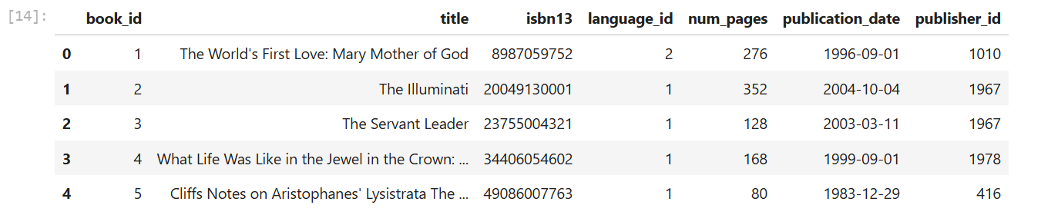

NOTE: to select data from other tables, we use the same python codes, after specifing the table name.Transforming data to fit the warehouse schema.
###check for null values
selectedData.isnull().sum()
###replace null values with Unknown
selectedData.fillna("Unknown", inplace=True)
###check data types
selectedData.dtypes()
###Data from book table by picking same columns
New_BookData = bookData[['book_id','language_id']]
New_BookData2 = bookData[['publisher_id','isbn13','publication_date','num_pages']]
#### Output for new variables [New_BookData and New_BookData2]
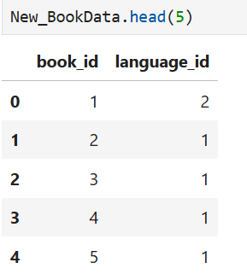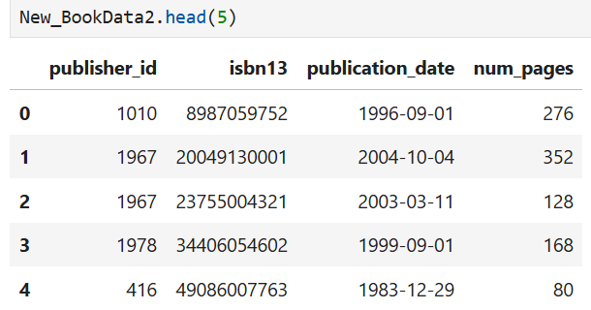

###Transform Data for DimBook table and rename columns names [Codes]
current_date = datetime.now()
New_BookData =
New_BookData.rename(columns= {'book_id':'book_id_BK','language_id':'language_id_BK'})
Newbook_authorData = Newbook_authorData.rename(columns= {'author_id':'author_id_BK'})
New_BookData2 = New_BookData2.rename(columns= {'publisher_id':'publisher_id_BK','isbn13':'isbn13','publication_date':'publication_date','num_pages':'num_pages'})
DimBookData = pd.concat([New_BookData,
Newbook_authorData,
New_BookData2,
Newbook_languageData,
NewpublisherData,
NewauthorData
],
axis=1, join='inner')
DimBookData['source_system_code'] = 'gravity_books'
DimBookData['start_date'] = current_date
DimBookData['end_date'] = pd.to_datetime('2025-12-31')
DimBookData['is_current'] = 1
DimBookData
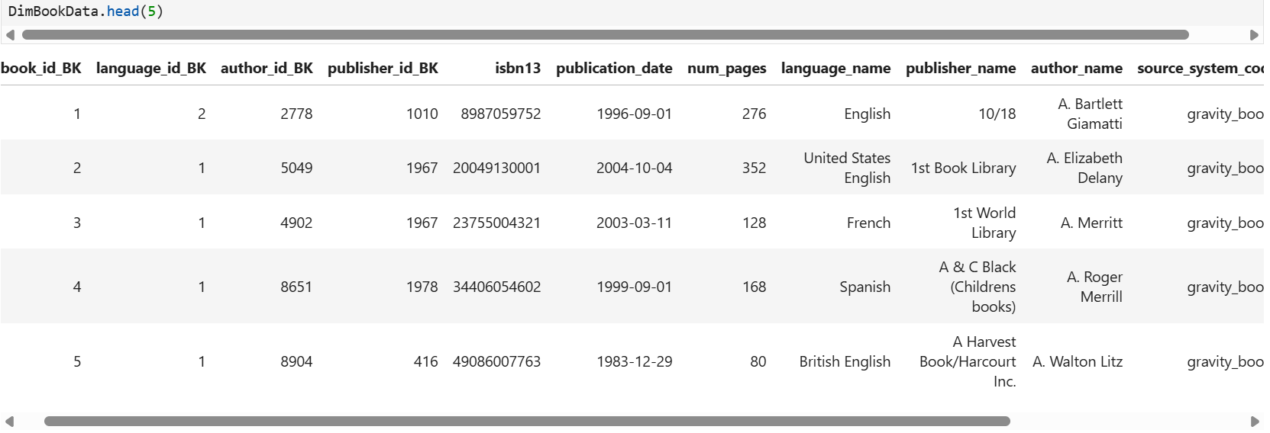

###Transform Data for DimCustomer [Codes]
NewCustomerData_customer_id = NewCustomerData_customer_id.rename(columns={'customer_id':'customer_id_BK'})
NewaddressData_address_id = NewaddressData_address_id.rename(columns={'address_id':'address_id_BK'})
NewcountryData_country_id = NewcountryData_country_id.rename(columns={'country_id':'country_id_BK'})
Newcustomer_address_address_id = Newcustomer_address_address_id.rename(columns={'address_id':'status_id_BK'})
Newcustomer_address_status_id = Newcustomer_address_status_id.rename(columns={'status_id':'address_status'})
DimCustomerData = pd.concat([NewCustomerData_customer_id,
NewaddressData_address_id,
NewcountryData_country_id,
Newcustomer_address_address_id,
countryData,
NewCustomerData,
NewaddressData,
Newcustomer_address_status_id
],
axis=1, join='inner')
DimCustomerData['source_system_code'] = 'gravity_books'
DimCustomerData['start_date'] = current_date
DimCustomerData['end_date'] = pd.to_datetime('2025-12-31')
DimCustomerData['is_current'] = 1
DimCustomerData
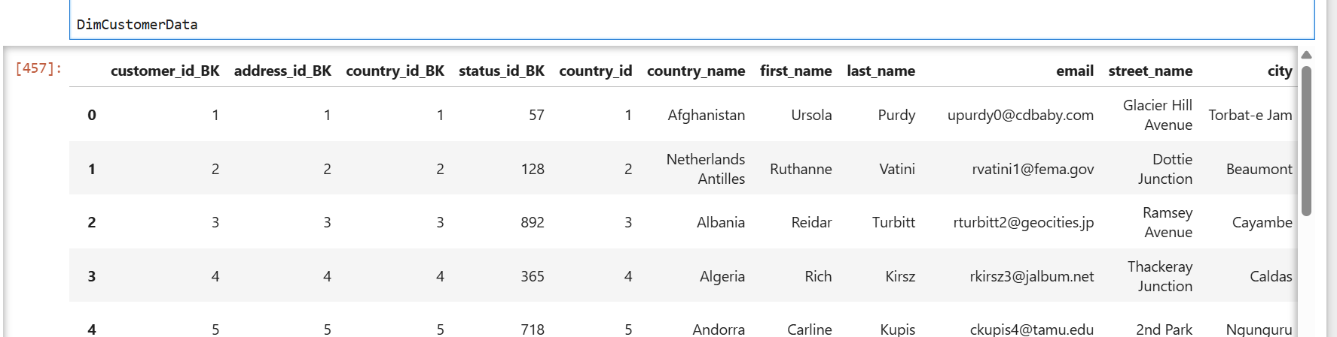
###Transform Data for DimDate [Codes]
current_date = datetime.now()
today = datetime.today().date()
# set DimDateData_is_current columns by comparing order_historyData['status_date'] value and to Day
order_historyData['is_current'] = (order_historyData['status_date'].dt.date == today).astype(int)
DimDateData_is_current = order_historyData['is_current']
# set DimDateData_end_date columns by adding 5 years to order_historyData['status_date'] value
order_historyData['end_date'] = order_historyData['status_date']
DimDateData_end_date = order_historyData['end_date'] + pd.DateOffset(years=5)
DimDateData = pd.concat([ order_historyData_year,
order_historyData_month,
order_historyData_day
],
axis=1, join='inner')
DimDateData['start_date'] = order_historyData['status_date']
DimDateData['end_date'] = DimDateData_end_date
DimDateData['is_current'] = DimDateData_is_current

DimDateData
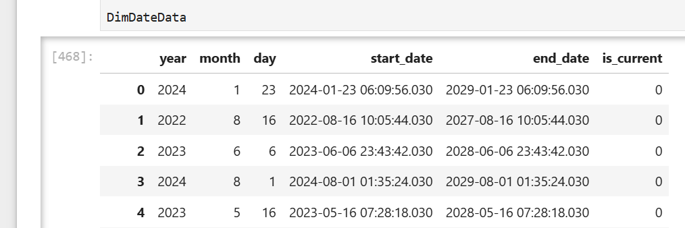

###Transform Data for DimOrder [Codes]
Newshipping_methodData_method_id_name = Newshipping_methodData_method_id_name.rename(columns={'method_id': 'method_id_bk'})
cust_orderData_order_date = cust_orderData_order_date.rename(columns={'order_date':'start_date'})
cust_orderData_order_date = cust_orderData_order_date.rename(columns={'order_date':'start_date'})
today = datetime.today().date()
order_historyData['end_date'] = order_historyData['status_date']
DimOrderData_end_date = order_historyData['end_date'] + pd.DateOffset(years=3)
DimOrderData = pd.concat([ Newshipping_methodData_method_id_name,
cust_orderData_order_date
],
axis=1, join='inner')
DimOrderData['source_system_code'] = 'gravity_books Database'
DimOrderData['start_date'] = order_historyData['status_date']
DimOrderData['end_date'] = DimOrderData_end_date
DimOrderData['is_current'] = DimDateData_is_current
DimOrderData
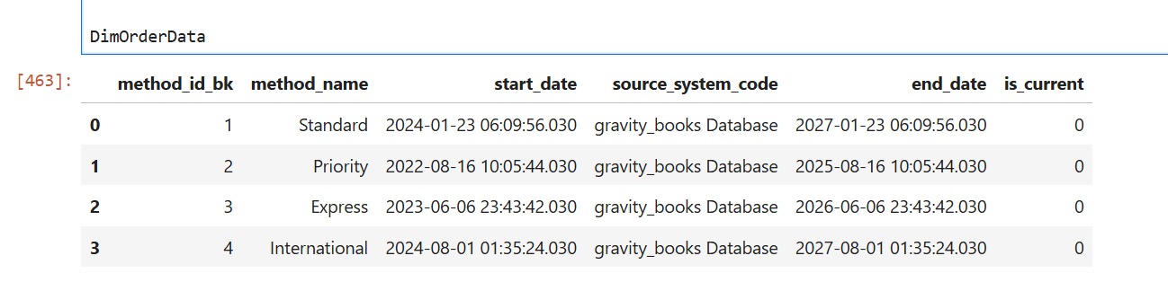

- Loading data into the data warehouse.
Data warehouse schema
Database Connection for Data warehouse
conn = pyodbc.connect("
DRIVER={ODBC Driver 17 for SQL Server};
SERVER=DESKTOP-MF69IV4\\SQLEXPRESS;
DATABASE= Data_warehouse;
Trusted_Connection=yes
")
Load Data into DimCustomer Table
cursor = conn.cursor()
insert_query = """INSERT INTO DimCustomer (customer_id_BK, address_id_BK, country_id_BK, tatus_id_BK,
first_name, last_name, email, country_name, street_name, city, address_status, source_system_code, start_date, end_date, is_current
)
VALUES
(?, ?, ?, ?, ?, ?, ?, ?, ?, ?, ?, ?, ?, ?, ?)"""

for index, row in DimCustomerData.iterrows():
cursor.execute(insert_query, (row['customer_id_BK'], row['address_id_BK'], row['country_id_BK'],
row['status_id_BK'], row['first_name'], row['last_name'], row['email'], row['country_name'],
row['street_name'], row['city'], row['address_status'], row['source_system_code'], row['start_date'], row['end_date'], row['is_current']
))
conn.commit()
print("Data inserted successfully into dbo.DimCustomer table.")
Retrieve Data of DimDate from Data warehouse
cursor.execute("SELECT * FROM DimDate")
rows = cursor.fetchall()
data = [list(row) for row in rows]
DimDate_column_names = [column[0] for column in cursor.description]
# Define your own column names
DimDate_column_names = ['date_id_SK', 'year', 'month', 'day', 'start_date', 'end_date', 'is_current']
# Create a Pandas DataFrame with your custom column names
DimDateData = pd.DataFrame(data, columns = DimDate_column_names )
DimDateData [OUTPUT]
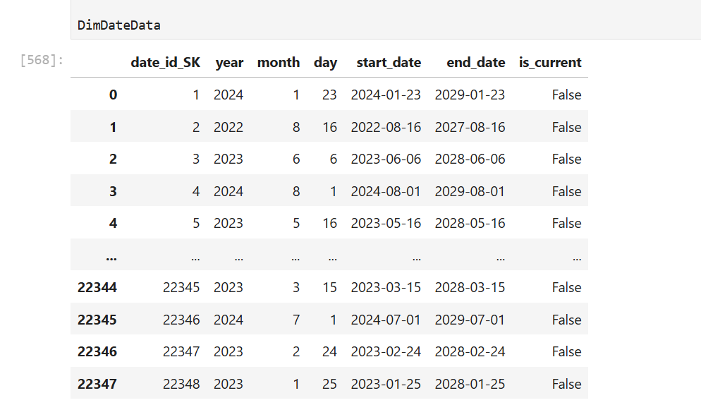
Foreign Keys From Dimention Tables
DimDateData_date_id_SK = DimDateData[['date_id_SK']]
DimBookData_book_id = DimBookData[['book_id_SK']]
DimCustomerData_customer_id_SK = DimCustomerData[['customer_id_SK']]
DimOrderData_method_id_SK = DimOrderData[['method_id_SK']]
### Transform Data for FactOrder [Codes]
current_date = datetime.now()
Neworder_lineData_line_id = Neworder_lineData_line_id.rename(columns={'order_line':'line_id'})
NewDimDateData_date_id_SK = DimDateData_date_id_SK.rename(columns={'date_id_SK':'order_history_id'})
NewDimBookData_book_id = DimBookData_book_id.rename(columns={'book_id_SK':'book_id'})
NewDimCustomerData_customer_id = DimCustomerData_customer_id_SK.rename(columns={'customer_id_SK':'customer_id'})
NewDimOrderData_method_id_SK = DimOrderData_method_id_SK.rename(columns={'method_id_SK':'shipping_method_id'})
Neworder_statusData_status_id= Neworder_statusData_status_id.rename(columns= {'status_id':'order_status_id'})
Neworder_statusData_status_value = Neworder_statusData_status_value.rename(columns={'status_value':'order_status'})
Neworder_lineData_price = Neworder_lineData_price.rename(columns={'price':'price'})
Newshipping_methodData_cost = Newshipping_methodData_cost.rename(columns={'cost':'shipping_cost'})
Newcust_orderData_created_at = cust_orderData_order_date.rename(columns={'start_date':'created_at'})
FactOrderData = pd.concat([
Neworder_lineData_line_id,
NewDimDateData_date_id_SK,
NewDimBookData_book_id,
NewDimCustomerData_customer_id,
NewDimOrderData_method_id_SK,
Neworder_statusData_status_id,
Neworder_statusData_status_value,
Neworder_lineData_price,
Newshipping_methodData_cost,
Newcust_orderData_created_at
],
axis=1, join='inner')
FactOrderData['source_system_code'] = 'gravity_books Database'
FactOrderData
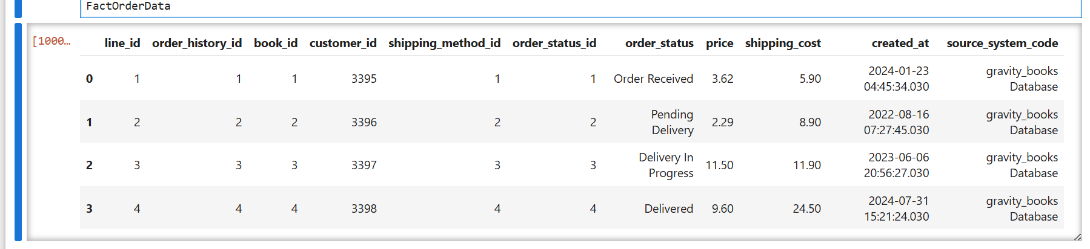

Load Data into FactOrder Table

insert_query = """INSERT INTO FactOrder ( line_id, order_history_id, book_id, customer_id, shipping_method_id,
order_status_id, order_status, price, shipping_cost, created_at, source_system_code)
VALUES
(?, ?, ?, ?, ?, ?, ?, ?, ?, ?, ?)"""

for index, row in FactOrderData.iterrows():
cursor.execute(insert_query, ( row['line_id'], row['order_history_id'], row['book_id'], row['customer_id'],
row['shipping_method_id'], row['order_status_id'], row['order_status'], row['price'], row['shipping_cost'],
row['created_at'], row['source_system_code'],
))
conn.commit()
print("Data inserted successfully into dbo.FactOrder table.")
cursor.execute("SELECT * FROM FactOrder")
rows = cursor.fetchall()
data = [list(row) for row in rows]
DimFactOrder_column_names = [column[0] for column in cursor.description]
# Define your own column names
DimOrder_column_names = ['order_id_SK','line_id', 'order_history_id', 'book_id', 'customer_id', 'date_Id_SK', 'order_status_id','order_status','price','shipping_cost','source_system_code','created_at']
# Create a Pandas DataFrame with your custom column names
FactOrderData = pd.DataFrame(data, columns = DimFactOrder_column_names )

FactOrderData
